Big Mountain Resort: A Data-Driven Strategy for Optimizing Ticket Pricing

Big Mountain Resort currently prices its adult weekend lift ticket at $81. To determine whether this is the optimal price point, I built a predictive model using data from similar resorts. The project began with detailed data wrangling—cleaning missing values, converting variables into usable formats, and preparing for in-depth analysis. Exploratory data analysis (EDA) revealed that while Big Mountain’s pricing is near the market median, it still sits below the revenue-maximizing range. As seen in the ticket price distribution (Figure 1), most resorts charge between $40 and $90, and Big Mountain’s current price is slightly below the peak of the market. This places the resort in a prime position to raise prices while remaining competitive.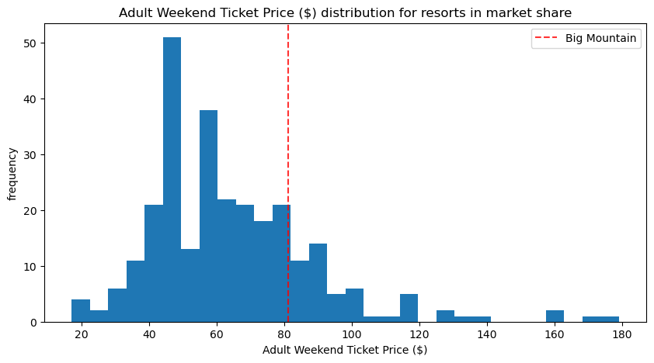Figure 1

What supports a higher ticket price is not merely competitor pricing, but the value the resort provides to its guests. Big Mountain demonstrates clear strengths in terrain and infrastructure. As illustrated in the total number of runs distribution (Figure 2), the resort offers significantly more skiable runs than the average competitor, placing it among the higher-performing resorts in the market. A greater number of runs allows for more variety, reduced congestion, and an overall enhanced guest experience—all of which justify a premium price point. These operational advantages reflect a level of infrastructure capable of supporting higher pricing and sustaining long-term brand value. The data clearly indicates that Big Mountain delivers above-average offerings relative to its current price.

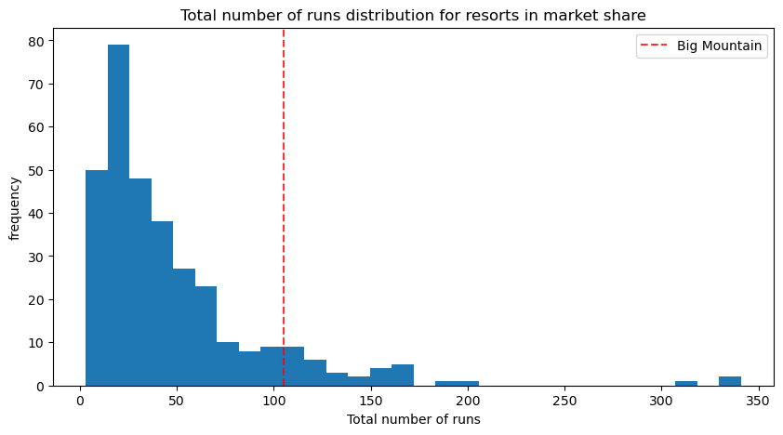Figure 2

To quantify the ideal pricing, I trained three regression models—linear, decision tree, and random forest—and evaluated them using RMSE and R² metrics. The random forest model outperformed the others and was selected as the winning model. Using this model for scenario simulation, I plotted predicted revenue against ticket prices and found that revenue peaks at approximately $94.22—a full $13 above the current price. The resulting curve (Figure 3) shows a clear revenue-maximizing point before returns diminish. This analysis provides clear support for a price increase, as the data identifies a specific price point at which revenue is maximized. The optimal pricing strategy is well-defined and supported by model predictions.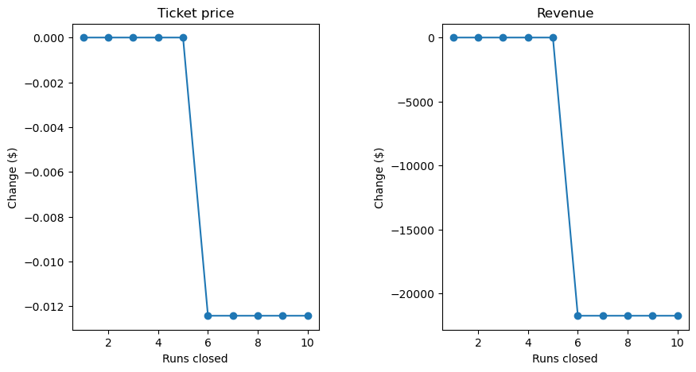Figure 3

Based on these findings, I recommend that Big Mountain Resort increase its adult weekend ticket price to $94.22, implementing the change gradually to monitor customer response and avoid sticker shock. The model-backed visuals support this adjustment and show Big Mountain has the features to justify the increase—especially its large number of runs and value-rich experience. For future work, I suggest incorporating dynamic pricing based on seasonal demand, weather, and visitor trends. Additional data on customer satisfaction, booking behaviors, and regional competitor moves can help refine the pricing model even further. With this strategy, Big Mountain can evolve into a data-powered, revenue-maximizing machine—without sacrificing its brand or guest experience.